Digital solution for a guide to make the student capable of hopping into the corporate world

# Kiruthika M,

Department of computer science engineering, Panimalar engineering college, Anna university, Chennai [kirukavi2000@gmail.com](mailto:kirukavi2000@gmail.com)

# Vinitha P,

Department of computer science engineering, Panimalar engineering college, Anna university,Chennai [vinivembu2000@gmail.com](mailto:%20%20%20%20%20%20%20%20%20%20%20vinivembu2000@gmail.com)

# Sinthiya G,

Department of computer science engineering, Panimalar engineering college, Anna university, Chennai, [sinthiyag2000@gmail.com](mailto:sinthiyag2000@gmail.com)

**D.Anuradha, Professor**,

Department of computer science engineering, Panimalar engineering college, Anna university, [vanu2020@gmail.com](mailto:vanu2020@gmail.com)

# Abstract:

Colleges are today considered as a stepping stone into the massive corporate world. In addition to top- class education, they have the responsibility of providing quality placements in a well-established company. Now they have realized that there was an urgent need to take up the responsibility to make the student industry ready from day one. Though many colleges and institutions have placement cells, the number of students who get placed is often low due to multiple issues. Even after having been placed, students are unable to cope with the expectations of the corporate world. Collaborative Learning (Digital Platform) is a digital platform which directs the students towards their goal to make them on par with the current industry demands. In this platform students are able to find the path towards their goal. This platform is tracked by a guide who is having his best of the knowledge on the current needs and trends.

**Keywords:** Collaborative learning, digital platform, knowledge sharing, k-means clustering.

# Introduction

During this current pandemic year, much like many industries, the education sector has gone through advancements due to technological innovations and the necessity. Even though the traditional classroom learning set works, now there is an urgent call for changing the old tradition of doing things manually. Covid-19 created a massive change in our daily life pattern. One of the major sectors affected by this pandemic situation is the education sector. The students are forcibly pushed to a new tradition where they develop themselves in their home. Schools and colleges play a major role in developing a student to get ready to face these current changing trends. The need for the modern world changes rapidly, the student should be given the best of the knowledge which makes them to satisfy the needs and requirements of the trend. Now there is an urgency to make the student industry ready in the early stages itself.

Hereby, college is the best environment where the student can find the best out of them and shape them into the person who suits the current industrial trend. Many students of our country have many different goals, ideas and talents. Even though having talents and ideas, the probability of students getting lost into the dark shadow of the fast- running world is very high. The major reason behind this is students have ideas, but they are unaware of how to develop it. They talents are not exposed because they don’t know where to express them.The most common and best solution for this issue is a guide. The student must have someone who has the knowledge of how to develop his/her ideas, how to execute his/her talent and how to make the student find his/her strength.

A guide is a person who is like a torch for a student who is lost in the dark forest.Colleges provide such guides, but in this pandemic situation the monitoring of the students manually by the guide becomes a problem. This paper is a solution to this problem. The guides can monitor and guide the students by using a website interaction between a student and a guide. This interaction starts from the very beginning.

# Queries

* + How do you deal with managing student- related information such as grades and scores?
  + How to help with the guide in analyzing the qualities of each student?
  + What do you do when disasters strike, for instance, the COVID-19 virus causing lockdown on a global scale and students cannot come to schools and colleges?
  + How do you help educators provide the best learning experiences while making sure that they are working efficiently?
  + How to make a student exposed to quality and necessary courses?
  + Moreover, what can you do to improve access to course materials?

# Methodology of the Module

## Student Module

In a recent analysis, almost 50% of respondents prefer online courses due to existing commitments. Furthermore, specific subjects that usually do not receive significant funding in our traditional educational setting can now be offered online. In this digital platform, students are recommended with courses other than normal academic subjects. Students are given a list of skills where they can view the course requirements to acquire the particular skill. This helps the student to get a clear cut idea of the things they study.

Thousands and thousands of courses are available on the internet today. However, the courses recommended on our digital platform differs from these. The courses recommended in this platform are filtered out of the courses available on the internet. The quality of the course subjects and lectures are chosen by analyzing the past reviews, likes and rating given. The course recommendations will be maintained by the guide. If the student/guide feels that the course present in the recommendations are not up to the mark, then that particular course will be removed from displaying. The students are also able to view the highest recommended courses by other colleges as trending courses. This helps the students to get exposed to a habit of developing themselves by knowledge sharing. In this current changing world, the habit of sharing things and ideas is missing. Many companies try to bring back this habit within their employees by conducting webinars, trainings and meetings.

Furthermore, the students are also given a chance to identify their interests. This is done by making the students answer a set of questions. These are indirect questions set which can predict the percentage of interest of students in the trending courses and growing technology.

## Guide Module

The guides are the ones who monitor the students in this digital platform. They have the responsibility of providing the details about the course, managing the profile and maintaining the platform. Guides are given a detailed analysis of the students under his/her mentorship. The students are clustering and shown to the guide based on their skills, CGPA and eligibility for placements. This helps to guide the students by finding their interest. Students are analyzed in the earlier stage itself. This helps the guide to reframe the students into the right path. Guides have a special responsibility of providing details about the placements to the final-year students.

# Algorithm

The students are clustered and displayed to the guide using k-means clustering. First, we must know what is meant by clustering. It is an algorithm which groups the unsupervised data. It is a methodology of machine learning concept. In this method of learning, the inferences are observed from the data set which does not contain labelled output variable. It is an exploratory data analysis technique that gives us an easy way to analyze the multivariate data sets. It is a way of dividing the data set into the number of clusters required, in such a way that the points belonging to the cluster have similar qualities. A cluster is a group of data points or objects in a data set that are similar to the other objects in the group, and dissimilar to the points in other clusters

The K-means clustering is one of the most used clustering algorithms due to its simplicity. It is a type of partitioning clustering algorithm. It divides the data present into k non-overlapping subsets, without any cluster-internal structure or labels. This means K- means clustering is an unsupervised algorithm. The similarity of the objects within a cluster is very less, and the objects across the clusters are very high or dissimilar. Conventionally, the distance of the sample from each other is used to shape the clusters. The k- means tries to decrease the “intra-cluster” distances and increase the

“inter-cluster” distances. The feature set has to be normalized to get the accurate dissimilarity measures. There are other dissimilarity measures as well that can be used for this purpose, but it depends on data type and also the domain that clustering is done for it.

The working of the k-means algorithm is as follows:

1. Determine the number of clusters.
2. The Next step is to randomly pick up the center point for the clusters.
3. Assigning the data points to the center point closest. This is done by calculating the distance between each data point from the centroid points.
4. Each cluster center is now updated to be the mean for data points in the cluster.
5. Now we have to once again calculate the distance of the data points from the new centroids. The points are re-clustered and the centroids moved. This is repeated until the centroid no longer moves.
6. These results with the densest clusters or the clusters with minimum errors.

In this paper, the k-means uses certain traits such as CGPA, number of backlogs and certifications made by students to cluster them into a specific group. By doing so, the guide gets a clear view about the level of the students under his/her mentorship. Clustering based on CGPA shows the interest of a student in his or her academic learning.

Clustering the students based on his certification shows the interest of the student in getting knowledge other than academic subjects. By these classification, the guide can easily split the student based on his/her ability, this helps him to choose a better way of training to those students who are really in need of it. The guide’s major and foremost work is analyzing and understanding students under his/her mentorship. Our paper helps him to do his/her job in a more easier way.

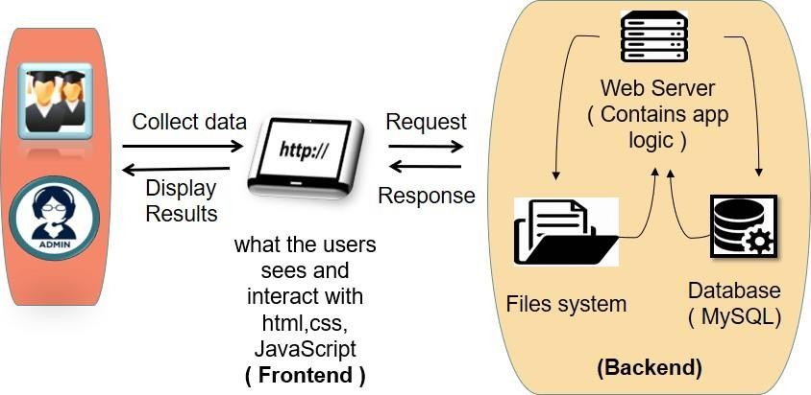

**Figure 1.** System Architecture Diagram

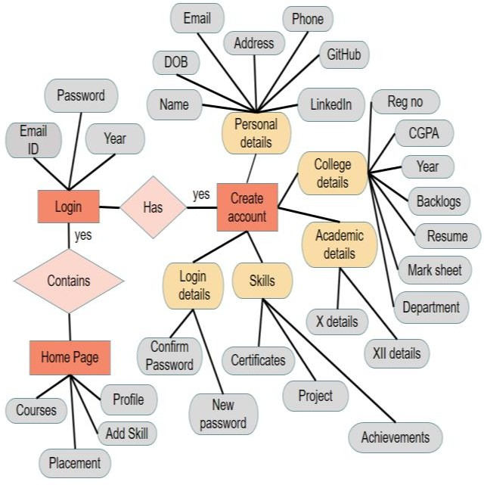 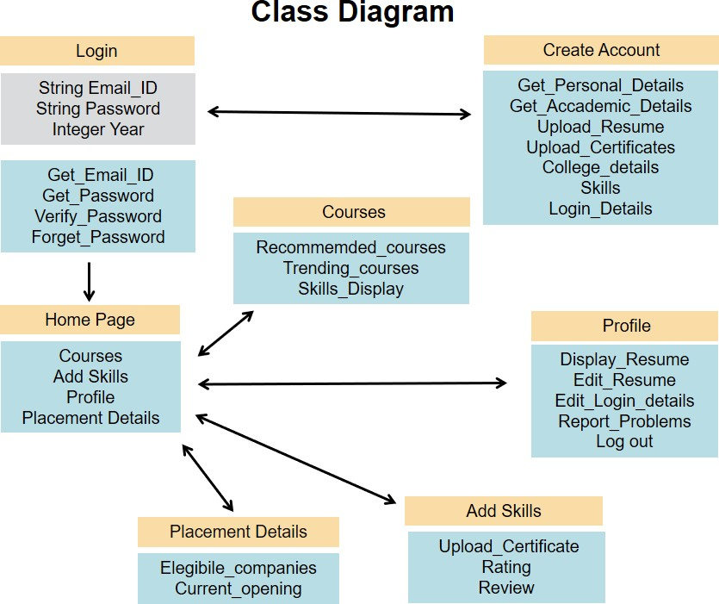

**Figure 2.** User module Component **Figure 3.** Classes at user end

# Sample Output

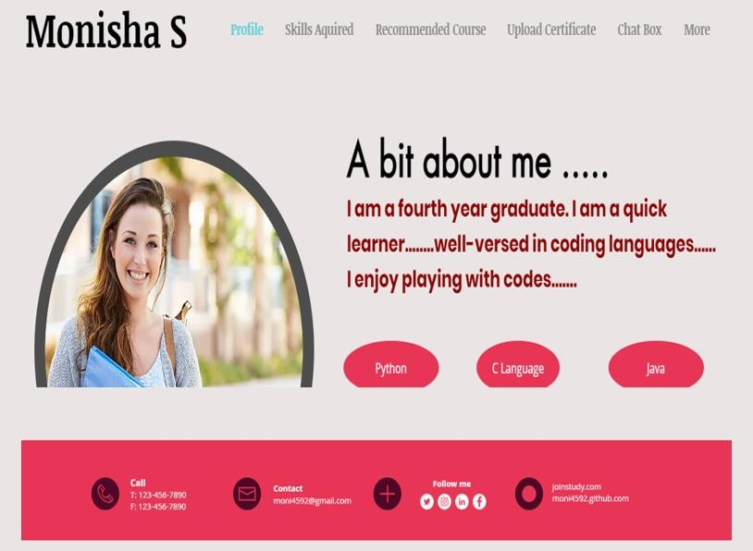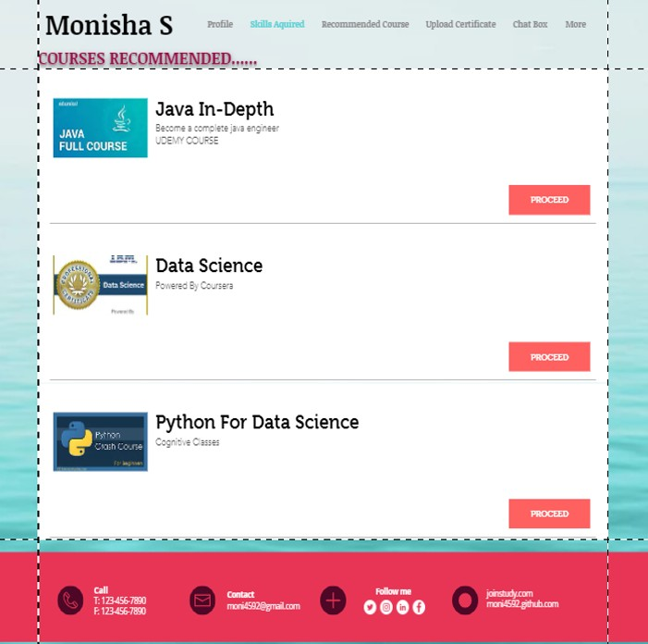

1. **Conclusion**

Collaborative learning (digital platform) is very useful to maintain demand supply between the institute and industry. In today’s world, sharing knowledge through the internet becomes the most effective way. This

platform cultivates the habit of upskilling a student by sharing the knowledge they gain. This quality is very much needed for the companies. Students are monitored and focused by a guide to track them on the right path to gain

their knowledge. Many students didn’t get enough information about what to learn, where to learn, what is expected, what is the eligibility criteria required by the companies. This digital platform acts as a solution for all these issues and improves their skills on their own. This makes them fix enough to all the needs and requirements of the growing industrial world by choosing the correct courses at the correct time.

# Related Study:

**Learning Management System (LMS) Success: An Investigation Among the University Students:** This paper gives us an idea about the factors involved in the success of LMS. The model was developed by

examining the relationship between students’ outcomes and information quality, system quality, and readiness for online learning. This is done through system use and user satisfaction. This project consists of a few disadvantages: This paper consists of data which has been collected in only one university, so we cannot guarantee that they are applicable to other universities.

**A survey paper on e-learning based on learning management system:** This paper is for the people who live in the rural area who suffer to study in their own place. This paper is all about a cloud-based learning system. The important features of this survey are automatic assignment evaluation with integration of plagiarism detector and keyword matching, web-based virtual workshop management and single sign on.

**Web-based Learning Management System Considerations for Higher Education:** This paper is made only for higher education, and this is modified based on technology acceptance model (TAM). This paper gives a solution of unlimited distance education with flexible learning timing. The key features of this paper are transmitting course content, evaluating students, evaluating course and instructors, creating class discussion, creating computer-based instructions, in addition to midterm exam course information, article reading and specific task.

**Online Learning Management System:** This project is for coding test like Hacker Rank.

Especially, the author adopted C and PHP to program the online judge module. Finally, there is a simple website demo that has been implemented on the basis of OJ module in order to demonstrate the usage of the proposed system and online judge module. This project consists of 4 processes, such as profiling preprocessing section, profiling compilation section, the operative part of the evaluation function, profiling answer judgment section.

# References:

1. Zheng Ninghan, Tian Shuzhen and Chen Yongqiang (2015) Online Learning Management System, International Conference on Computational Science and Computational Intelligence
2. Seyed Mohammadbagher Jafari, Suha Fouad, Mohaddece Sadat Moaddab and Sharif Omar (2015) Learning Management System (LMS) Success: An Investigation Among the University Students, IEEE Conference on e-Learning, e-Management and e-Services
3. Chih-Hung Chung, Laura A and Chang E. Koh (2013) Web-based Learning Management System Considerations for Higher Education, Article in International Journal of Scientific and Engineering Research
4. Chirag Patel, Mahesh Gadhavi, Dr. Atul Patel (2013) A survey paper on e-learning based learning management Systems (LMS), Article in International Journal of Scientific and Engineering Research
5. Shi Na, Liu Xumin and Guan Yong (2010) Research on k-means Clustering Algorithm: An Improved k-means Clustering Algorithm, Third International Symposium on Intelligent Information Technology and Security informatics.
6. Oyelade, O. J, Oladipupo, O. O and Obagbuwa, I. C (2010) Application of k-Means Clustering algorithm for prediction of Students’ Academic Performance, International Journal of Computer Science and Information Security
7. Saroj, Tripti Chaudhary (2015) Study on Various Clustering Techniques, International Journal of Computer Science and Information Technologies
8. Kamalpreet Bindra, Anuranjan Mishra (2017) A Detailed Study of Clustering Algorithms, IEEE
9. Patricia Fidalgo, Joan Thormann, Oleksandr Kulyk & José Alberto Lencastre (2020) Students’ perceptions on distance education: A multinational study, International Journal of Education Technology in Higher Education.
10. Nor Azura Adzharuddin (2013) learning Management System (LMS) among University Students: Does It Work? International Journal of e-Education e-Business e-Management and e-Learning